**MINISTRY OF EDUCATION AND TRAINING**

**DUY TAN UNIVERSITY**

---------------------------



**RENTING HELPER -**

**A SUPPORT SYSTEM FOR FINDING HOUSE FOR RENT ON ANDROID OS**

**MENTOR: TRINH SU TRUONG THI**

**TEAM MEMBERS**

1. **NGUYEN LUONG HOANG - 1560**
2. **NGUYEN NGOC VU - 1579**
3. **HUA THI THONG - 6419**
4. **NGUYEN DINH THI NGOC DIEP - 1558**
5. **TRAN VAN THANH - 1571**

***Da Nang, Mar-2018***

**CONTENT**

INTRODUCTION 1

1. Purpose 1

2. Proposed solution 1

3. Project goal 1

CHAPTER 1: PROJECT OVERVIEW 2

1.1. System overview 2

1.2 Development process 3

CHAPTER 2: ANALYSIS AND SYSTEM DESIGN 4

2.1. Describe the functions of the system 4

2.1.1. Actor 4

2.1.2. Use case diagram 4

CHAPTER 3: IMPLEMENT 14

3.1 Login 14

3.2 Main application 14

3.3 House’s detailed information 15

3.4 Posting house for rent 16

SUMMARY 17

4.1. Result 17

4.2. Limitation 17

# INTRODUCTION

## Purpose

Nowadays, demand of renting house or room is increasing dramatically. Especially, young people who are students or newly-graduated students, they don’t have much money to own a house, so they would prefer to rent a house or a room. But it would take them a lot of time and efforts to find a place they love. Therefore, Renting Helper is created with the purpose of helping house seekers to find their beloved home in an effortless and fastest way.

Renting Helper is an application which helps users to lookup all detailed information of houses for rent in a specific location. When you use this service, it gives you an exactly address, renting money, view of location, etc of houses for rent.

It also gives you an ability to post your house or room information to the system if you would like to rent your property.

## Proposed solution

Our team recommends building the “Renting Helper” application with some special features for users:

* Finding renting house/room
* Posting house/room for rent
* Viewing place on google map
* Contact house owner by supplied phone number
* Rating marks for renting place

## Project goal

* Build a system to help house seekers and house owners can contact each other easily
* Complete developing requirements and finish tasks on time

# CHAPTER 1: PROJECT OVERVIEW

## System overview

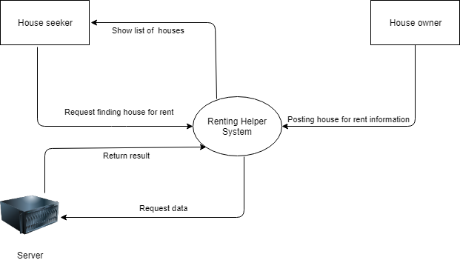

##### Figure 1.1: Context Diagram

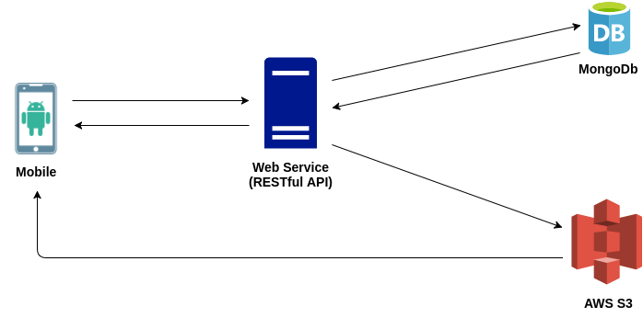

##### Figure 1.2: Architecture of the system

* **Mobile**: Written in Java Android
* **Web Service**: Developed on .Net core
* **MongoDb**: As a place to store program data
* **AWS S3**: As a place to store images

### Development process

* Process:
  + Scrum
* Technical:
  + .Net core
  + Android
  + Google Map API
  + MongoDb
  + AWS S3
* Tools:
  + Android Studio
  + Visual Studio
  + Trello
  + Gitlab

.

# CHAPTER 2: ANALYSIS AND SYSTEM DESIGN

## Describe the functions of the system

### Actor

* Guest
* User

## Use case diagram

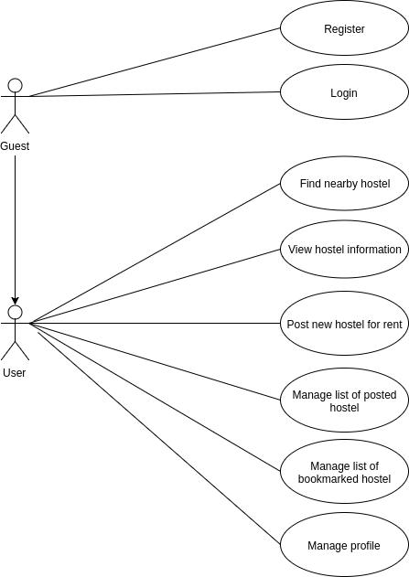

*Figure 2.1: Use Case Overview*

*Table 2.1: Use Case Overview*

|  |  |
| --- | --- |
| Use Case Name | Overview |
| Create By | Diep D. T. N. NGUYEN |
| Date Create | 15 – Feb – 2018 |
| Actors | User |
| Description | This use case describes how User uses the system to find house or post house for rent. |
| Trigger | The user indicates that they want to use the functions that they have selected. |
| Pre – Conditions | User logins the system successfully, and also need to choose what function they want. |
| Post – Conditions | The user will use the function that they have selected . |
| Normal Flow | Select the lookup: The system will show a list of house for rent available for user to choose.  User can click post house button if user wants to rent user’s house. |
| Alternative Flow | The system will return information that user have selected. |
| Exceptions |  |
| Include |  |
| Special Requirement | Software play on Android OS.  That function is existed. |

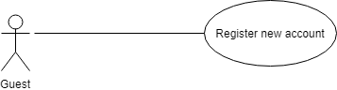

*Figure 2.2: Use Case Register*

*Table 2.2: Use Case Register*

|  |  |
| --- | --- |
| Use Case Name | Register |
| Create By | Diep D. T. N. NGUYEN |
| Date Create | 15 – Feb – 2018 |
| Actors | User |
| Description | This use case describes how user can register new account |
| Trigger | The user indicates that they want to use the functions that they have selected. |
| Pre – Conditions | Access the application |
| Post – Conditions | The user will use the function that they have selected. |
| Normal Flow | Input data to register a new account |
| Alternative Flow |  |
| Exceptions |  |
| Include |  |
| Special Requirement | Software play on Android OS.  That function is existed. |

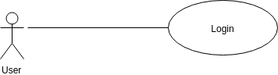

*Figure 2.3: Use Case Login*

*Table 2.3: Use Case Login*

|  |  |
| --- | --- |
| Use Case Name | Login |
| Create By | Diep D. T. N. NGUYEN |
| Date Create | 15 – Feb – 2018 |
| Actors | User |
| Description | This use case describes how user can log in to the application |
| Trigger | The user indicates that they want to use the functions that they have selected. |
| Pre – Conditions | User has an account |
| Post – Conditions | The user will use the function that they have selected. |
| Normal Flow | User input data to log in |
| Alternative Flow |  |
| Exceptions |  |
| Include |  |
| Special Requirement | Software play on Android OS.  That function is existed. |

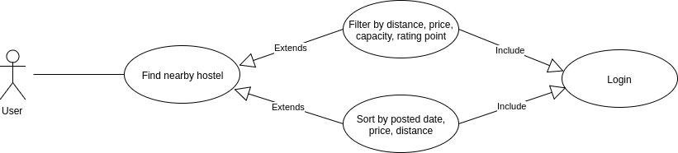

*Figure 2.4: Use Case Find renting house*

*Table 2.4: Use Case Find Renting House*

|  |  |
| --- | --- |
| Use Case Name | Find Renting House List |
| Create By | Diep D. T. N. NGUYEN |
| Date Create | 15 – Feb – 2018 |
| Actors | User |
| Description | This use case describes how user can find renting house. |
| Trigger | The user indicates that they want to use the functions that they have selected. |
| Pre – Conditions | User logins the system successfully |
| Post – Conditions | The user will use the function that they have selected. |
| Normal Flow | User filters conditions to find a house for rent fits their needs |
| Alternative Flow | The system will display house’s information |
| Exceptions |  |
| Include |  |
| Special Requirement | Software play on Android OS.  That function is existed. |

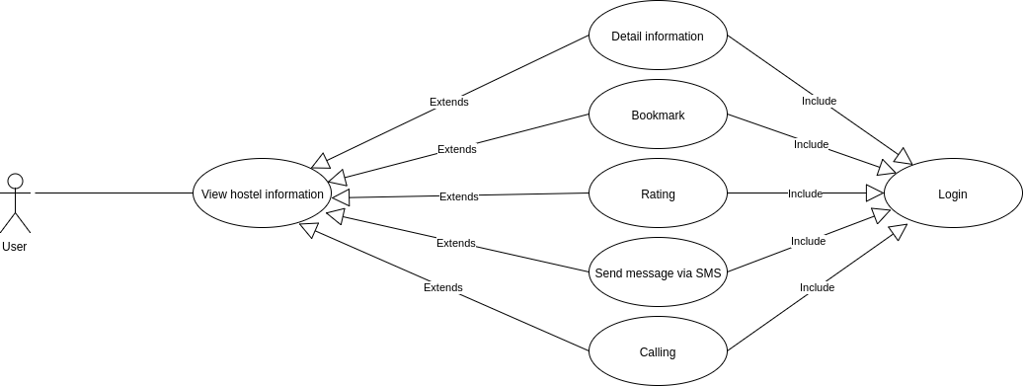

*Figure 2.5: Use Case View house’s information*

*Table 2.5: Use Case View house’s information*

|  |  |
| --- | --- |
| Use Case Name | View house’s information |
| Create By | Diep D. T. N. NGUYEN |
| Date Create | 15 – Feb – 2018 |
| Actors | User |
| Description | This use case describes what user can do when viewing house’s information |
| Trigger | The user indicates that they want to use the functions that they have selected. |
| Pre – Conditions | User logins the system successfully |
| Post – Conditions | The user will use the function that they have selected. |
| Normal Flow | User chooses a location  Click on a house to view detail information  Click on address to view location on map  Click on owner’s phone number to make a phone call  Rate marks |
| Alternative Flow | The system will display house’s information |
| Exceptions |  |
| Include |  |
| Special Requirement | Software play on Android OS.  That function is existed. |

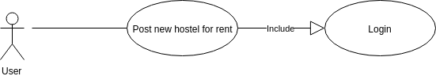

*Figure 2.6: Use Case Post house for rent*

*Table 2.6: Use Case Post house for rent*

|  |  |
| --- | --- |
| Use Case Name | Post house for rent |
| Create By | Diep D. T. N. NGUYEN |
| Date Create | 15 – Feb – 2018 |
| Actors | User |
| Description | This use case describes how user post their house information to the system so that other people can rent it. |
| Trigger | The user indicates that they want to use the functions that they have selected. |
| Pre – Conditions | User logins the system successfully |
| Post – Conditions | The user will use the function that they have selected. |
| Normal Flow | User click post house button  Input house’s information  Post images  Input house’s location |
| Alternative Flow | The system will display guide to show the suggest way step by step. |
| Exceptions |  |
| Include |  |
| Special Requirement | Software play on Android OS.  That function is existed. |

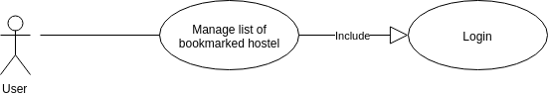

*Figure 2.7: Use Case Manage bookmarked houses for rent*

*Table 2.7: Use Case Manage bookmarked houses for rent*

|  |  |
| --- | --- |
| Use Case Name | Manage bookmarked houses for rent |
| Create By | Diep D. T. N. NGUYEN |
| Date Create | 15 – Feb – 2018 |
| Actors | User |
| Description | This use case describes how user manage their bookmarked houses |
| Trigger | The user indicates that they want to use the functions that they have selected. |
| Pre – Conditions | User logins the system successfully |
| Post – Conditions | The user will use the function that they have selected. |
| Normal Flow | User clicks navigation button  Click bookmarked list menu |
| Alternative Flow | The system will display guide to show the suggest way step by step. |
| Exceptions |  |
| Include |  |
| Special Requirement | Software play on Android OS.  That function is existed. |

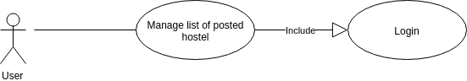

*Figure 2.8: Use Case Manage posted houses for rent*

*Table 2.8: Use Case Manage posted houses for rent*

|  |  |
| --- | --- |
| Use Case Name | Manage posted houses for rent |
| Create By | Diep D. T. N. NGUYEN |
| Date Create | 15 – Feb – 2018 |
| Actors | User |
| Description | This use case describes how user manage their posted houses |
| Trigger | The user indicates that they want to use the functions that they have selected. |
| Pre – Conditions | User logins the system successfully |
| Post – Conditions | The user will use the function that they have selected. |
| Normal Flow | User clicks navigation button  Click posted houses list menu |
| Alternative Flow | The system will display guide to show the suggest way step by step. |
| Exceptions |  |
| Include |  |
| Special Requirement | Software play on Android OS.  That function is existed. |

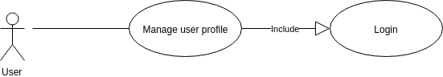

*Figure 2.9: Use Case Manage user profile*

*Table 2.9: Use Case Manage user profile*

|  |  |
| --- | --- |
| Use Case Name | Manage user profile |
| Create By | Diep D. T. N. NGUYEN |
| Date Create | 15 – Feb – 2018 |
| Actors | User |
| Description | This use case describes how user manages user’s profile |
| Trigger | The user indicates that they want to use the functions that they have selected. |
| Pre – Conditions | User logins the system successfully |
| Post – Conditions | The user will use the function that they have selected. |
| Normal Flow | User clicks navigation button  Click Account menu |
| Alternative Flow | The system will display guide to show the suggest way step by step. |
| Exceptions |  |
| Include |  |
| Special Requirement | Software play on Android OS.  That function is existed. |

# 

# CHAPTER 3: IMPLEMENT

### Login

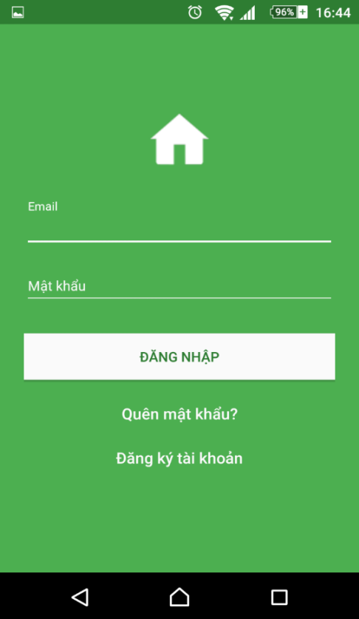

*Figure 3.1: Login*

### Main application

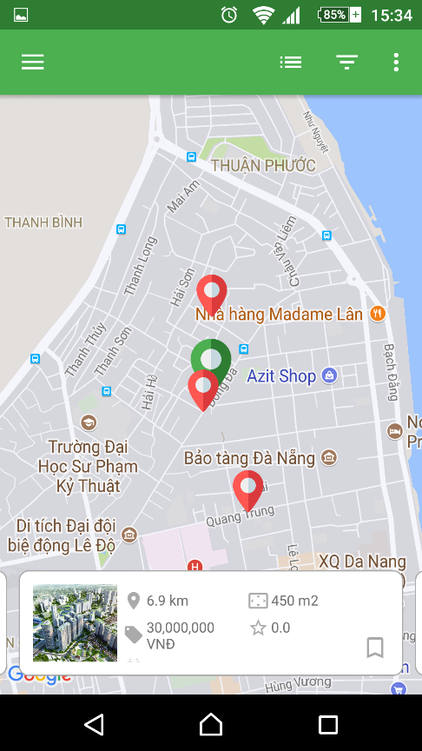

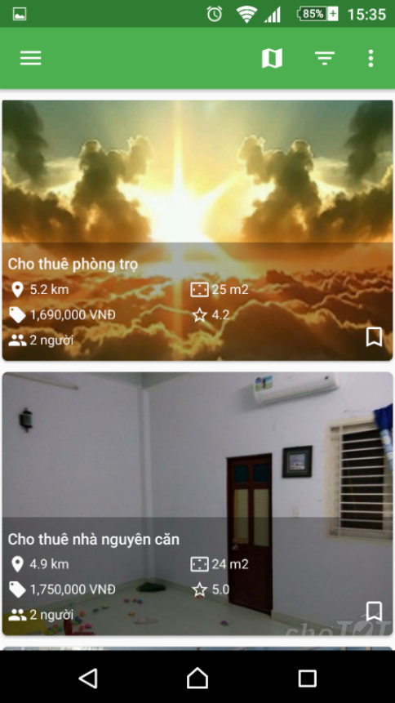

*Figure 3.2: Main application*

### House’s detailed information

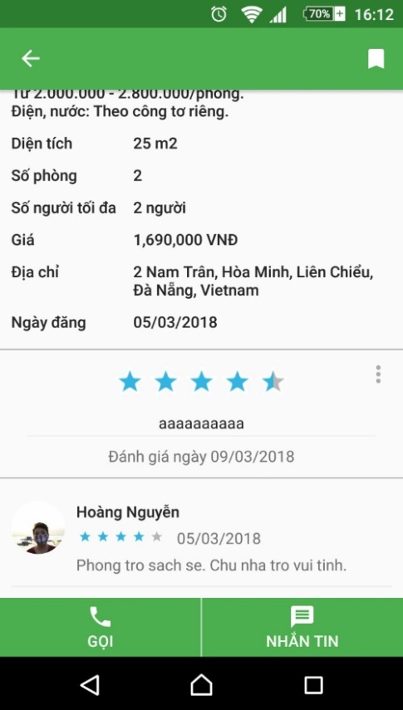

*Figure 3.3: House’s for rent detailed information*



### Posting house for rent

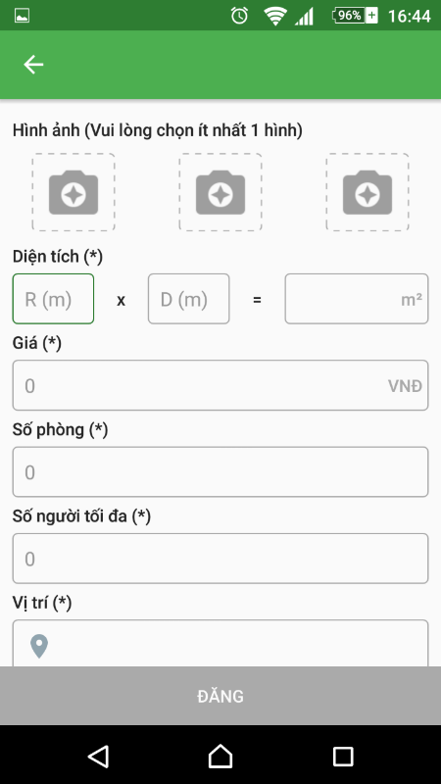

*Figure 3.4: Posting house for rent*

# SUMMARY

## Result

* Learn the process of building a mobile software with new technologies such as Google Map, open source libraries, and new designs that make the product look more beautiful and user-oriented.
* Apply the knowledge learned in product development.
* Improve the responsibility of work, self-discipline, seriousness, punctuality.
* Improve reading comprehension skills - understand English.
* Drawing on valuable experience, self-learning, self-study, soft skills as well as working environment in professional and new perspective on future work.

## Limitation

* Due to limited knowledge and experience as well as programming skills, the software products are still simple and have not been fully implemented.
* Not yet implement new posted house approval feature
* Not yet implement push notification when a house is rated
* Not yet implement shared room/house feature
* The program is only focused on a major function, not yet usable on a large scale.